Euler Line Theorem
# Source: AI Source: Provided by: [Data Path: Persons Table -> ID Column: 1, Name_En Column: Motasem Essam] -> From: [ChatGPT] on [7/25/2026]
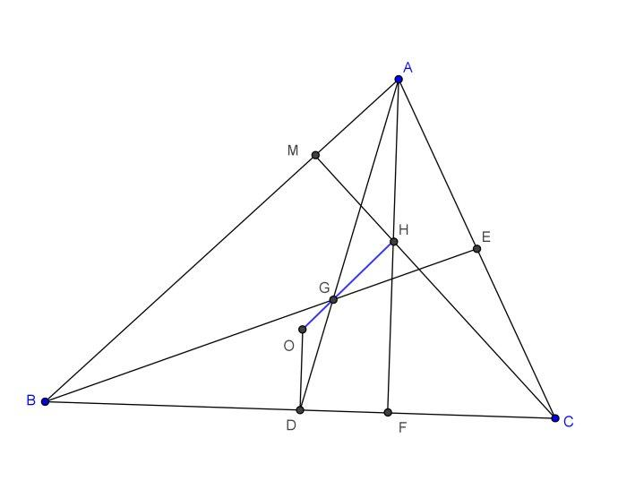
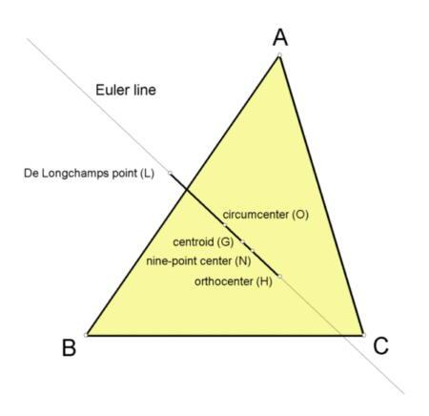
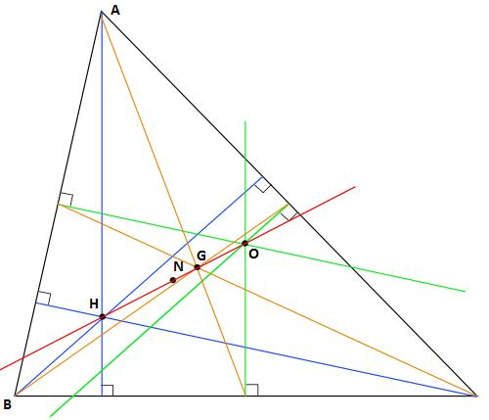

Definition
# Source: AI Source: Provided by: [Data Path: Persons Table -> ID Column: 1, Name_En Column: Motasem Essam] -> From: [ChatGPT] on [7/25/2026]
The Euler Line Theorem states that in every non-equilateral triangle, the circumcenter $O$, centroid $G$, and orthocenter $H$lie on a single straight line called the Euler line.
$$\boxed{O, G, H\text{ are collinear}}$$
The theorem also establishes a fixed ratio between the distances from the centroid to the circumcenter and orthocenter:
$$\boxed{OG:GH=1:2}$$
Therefore,
$$\boxed{GH=2OG}$$
and
$$\boxed{OH=3OG}$$

Purpose
# Source: AI Source: Provided by: [Data Path: Persons Table -> ID Column: 1, Name_En Column: Motasem Essam] -> From: [ChatGPT] on [7/25/2026]
The Euler Line Theorem is used to:
- Establish a relationship between important triangle centers.
- Prove that $O$, $G$, and $H$are collinear.
- Determine distances between triangle centers.
- Study the geometric structure of triangles.
- Solve coordinate-geometry problems involving triangle centers.
- Connect the circumcenter, centroid, and orthocenter.

Fundamental Elements
# Source: AI Source: Provided by: [Data Path: Persons Table -> ID Column: 1, Name_En Column: Motasem Essam] -> From: [ChatGPT] on [7/25/2026]
The theorem involves three principal triangle centers:
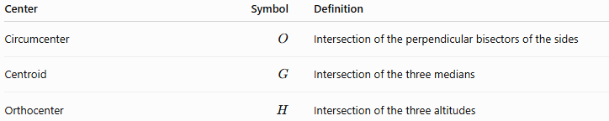
Center | Symbol | Definition
Circumcenter | $$O$$ | Intersection of the perpendicular bisectors of the sides
Centroid | $$G$$ | Intersection of the three medians
Orthocenter | $$H$$ | Intersection of the three altitudes
These three points satisfy:
$$\boxed{O-G-H\text{ are collinear}}$$
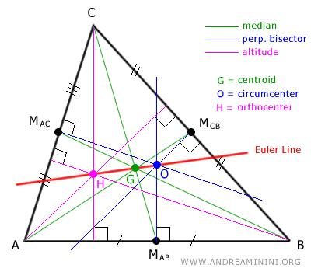
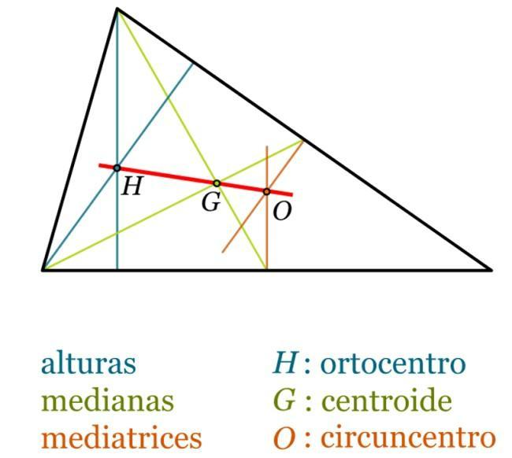

Euler Line
# Source: AI Source: Provided by: [Data Path: Persons Table -> ID Column: 1, Name_En Column: Motasem Essam] -> From: [ChatGPT] on [7/25/2026]
The straight line passing through $O$, $G$, and $H$is called the Euler line.
For a non-equilateral triangle:
$$\boxed{\text{Euler Line}=OGH}$$
The centroid divides the segment $OH$in the ratio $1:2$:
$$\boxed{OG:GH=1:2}$$
Thus, $G$is located one-third of the way from $O$to $H$:
$$\boxed{OG=\frac{1}{3}OH}$$
and
$$\boxed{GH=\frac{2}{3}OH}$$

Statement of the Euler Line Theorem
# Source: AI Source: Provided by: [Data Path: Persons Table -> ID Column: 1, Name_En Column: Motasem Essam] -> From: [ChatGPT] on [7/25/2026]
Theorem:
In every non-equilateral triangle, the circumcenter, centroid, and orthocenter are collinear, and the centroid divides the segment joining the circumcenter and orthocenter in the ratio $1:2$.
Mathematically:
$$\boxed{O, G, H\text{ are collinear}}$$
and
$$\boxed{OG:GH=1:2}$$

Vector Form
# Source: AI Source: Provided by: [Data Path: Persons Table -> ID Column: 1, Name_En Column: Motasem Essam] -> From: [ChatGPT] on [7/25/2026]
The Euler Line Theorem has a particularly simple vector representation.
If $O$, $G$, and $H$are represented by position vectors, then:
$$\boxed{\vec{OH}=3\vec{OG}}$$
This immediately shows that $O$, $G$, and $H$lie on the same line.
Equivalently:
$$\boxed{\vec{OG}=\frac{1}{3}\vec{OH}}$$

Coordinate Form
# Source: AI Source: Provided by: [Data Path: Persons Table -> ID Column: 1, Name_En Column: Motasem Essam] -> From: [ChatGPT] on [7/25/2026]
If
$$O=\left(x_{O} , y_{O}\right)$$
and
$$G=\left(x_{G} , y_{G}\right),$$
then the orthocenter is:
$$\boxed{H=\left(3 , x_{G}-2x_{O} 3y_{G}-2y_{O}\right)}$$
This follows from:
$$\vec{OH}=3\vec{OG}$$
and provides a convenient method for finding the orthocenter when the circumcenter and centroid are known.

Proof of the Euler Line Theorem
# Source: AI Source: Provided by: [Data Path: Persons Table -> ID Column: 1, Name_En Column: Motasem Essam] -> From: [ChatGPT] on [7/25/2026]
Consider a triangle $ABC$.
Let its position vectors relative to an arbitrary origin be:
$$\vec{A}, \vec{B}, \vec{C}$$
The centroid $G$has position vector:
$$\boxed{\vec{G}=\frac{\vec{A}+\vec{B}+\vec{C}}{3}}$$
Now choose the circumcenter $O$as the origin. Let:
$$\vec{A}=\vec{a}, \vec{B}=\vec{b}, \vec{C}=\vec{c}$$
Because $O$is the circumcenter:
$$∣\vec{a}∣=∣\vec{b}∣=∣\vec{c}∣=R$$
The centroid therefore has vector:
$$\vec{OG}=\frac{\vec{a}+\vec{b}+\vec{c}}{3}$$
Define a point $H$by:
$$\vec{OH}=\vec{a}+\vec{b}+\vec{c}$$
Therefore:
$$\vec{OH}=3\vec{OG}$$
so:
$$\boxed{\vec{OH}=3\vec{OG}}$$
This proves that $O$, $G$, and $H$are collinear.
Furthermore:
$$OG=\frac{1}{3}OH$$
and therefore:
$$GH=OH-OG \\ GH=\frac{2}{3}OH$$
Hence:
$$\boxed{OG:GH=1:2}$$
Thus, the Euler Line Theorem is proved.

Relationship with the Nine-Point Center
# Source: AI Source: Provided by: [Data Path: Persons Table -> ID Column: 1, Name_En Column: Motasem Essam] -> From: [ChatGPT] on [7/25/2026]
The nine-point center $N$also lies on the Euler line.
The important relationship is:
$$\boxed{ON=NH=\frac{1}{2}OH}$$
Thus, the four important points can be arranged along the Euler line as:
$$\boxed{O - N - G - H}$$
for the usual configuration.
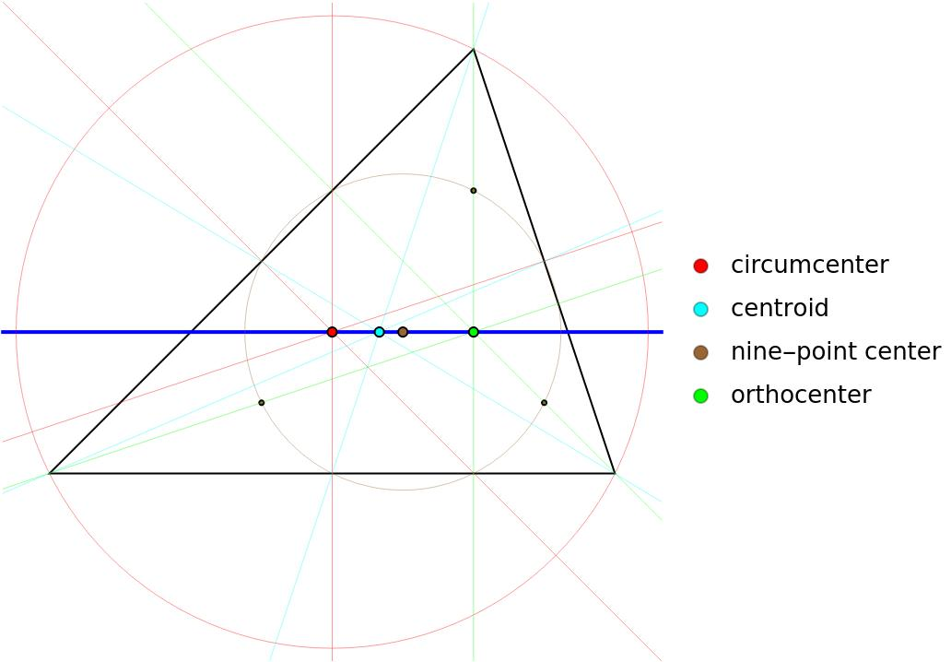
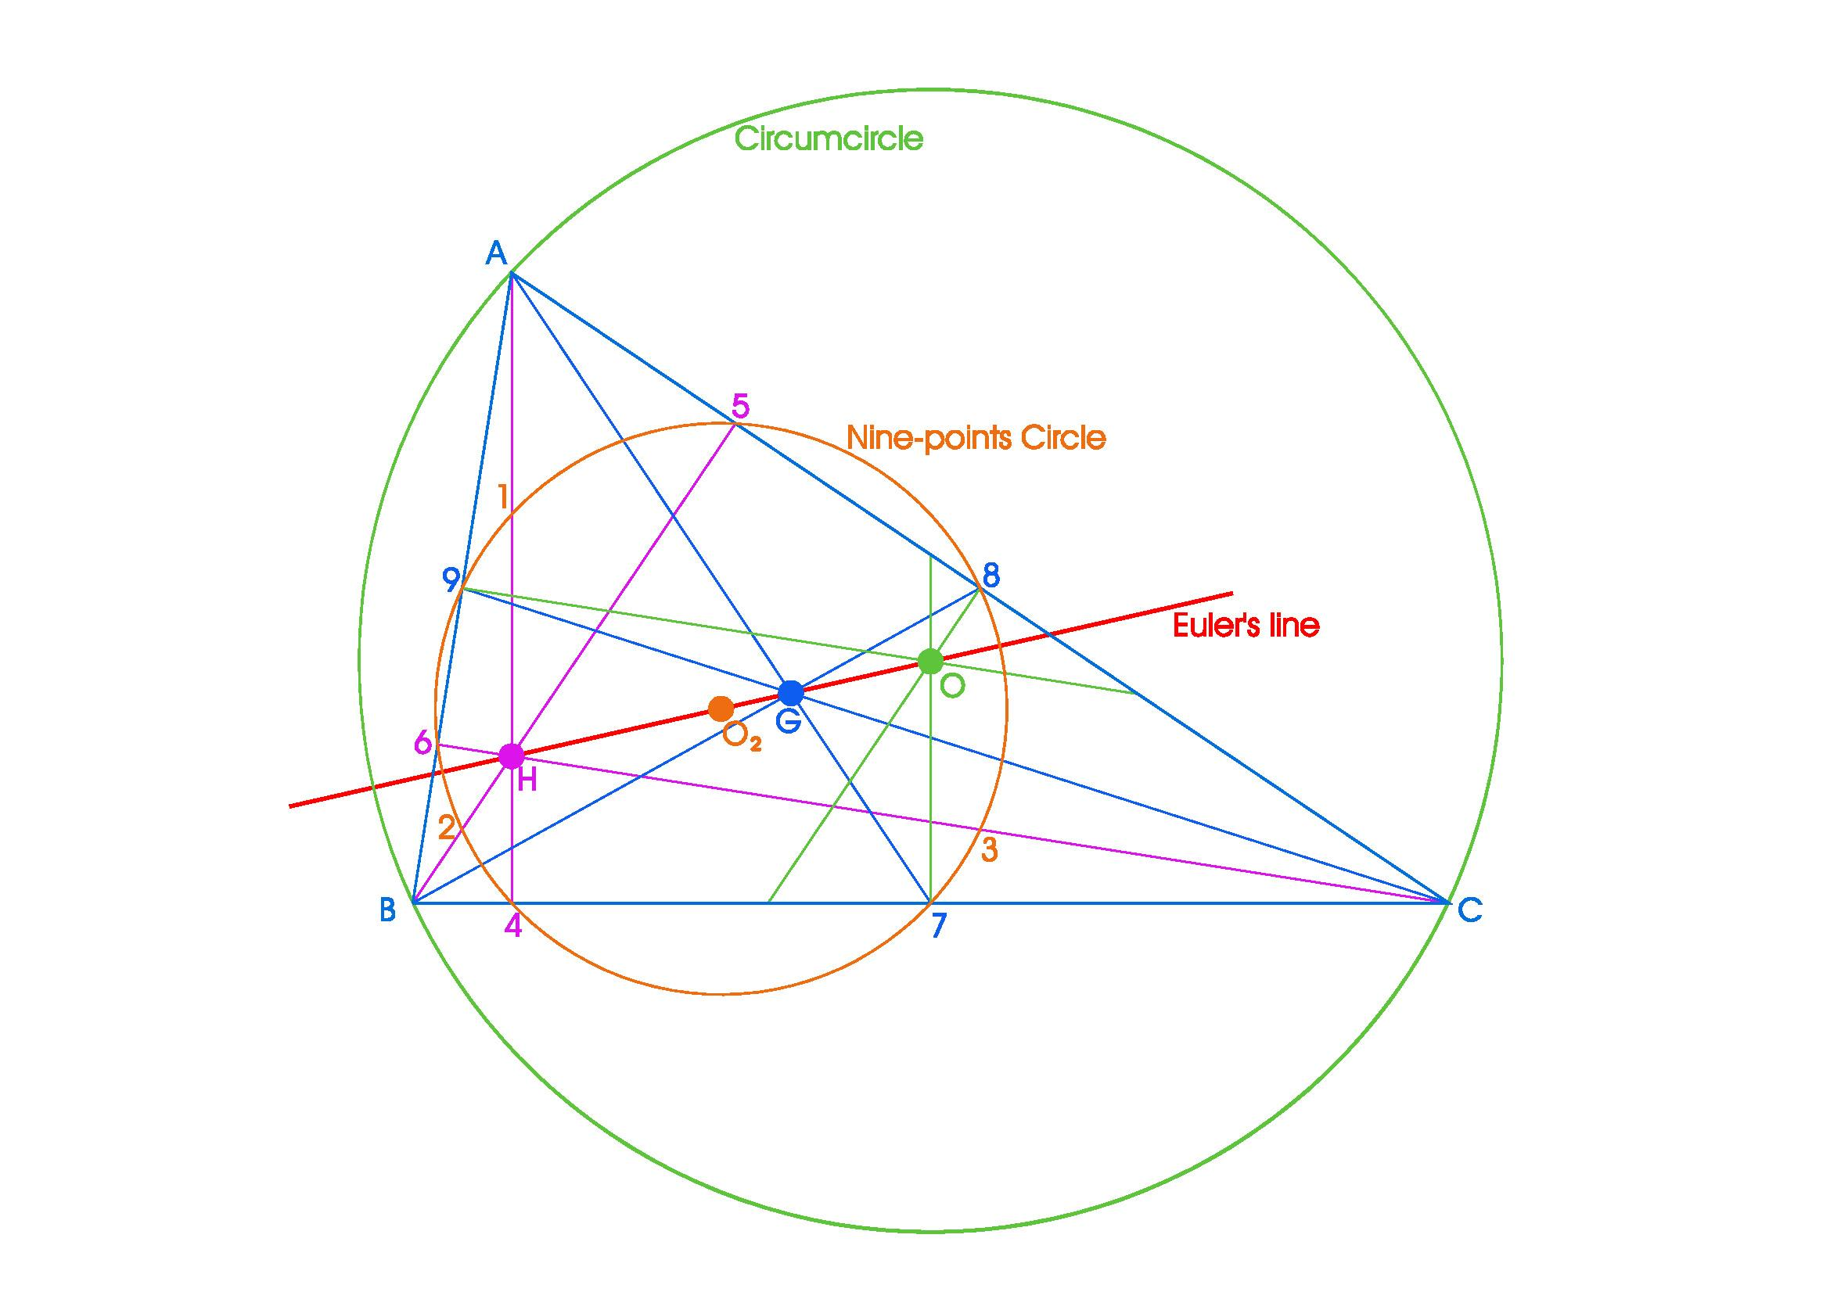
The exact ordering can vary with the triangle, but the collinearity and distance relationships remain valid.

Special Case: Equilateral Triangle
# Source: AI Source: Provided by: [Data Path: Persons Table -> ID Column: 1, Name_En Column: Motasem Essam] -> From: [ChatGPT] on [7/25/2026]
For an equilateral triangle, several important centers coincide:
$$\boxed{O=G=H=I}$$
where $I$is the incenter.
Therefore, the usual Euler line is not uniquely determined because all these centers are the same point.
So the theorem is normally stated for a non-equilateral triangle.

Example
# Source: AI Source: Provided by: [Data Path: Persons Table -> ID Column: 1, Name_En Column: Motasem Essam] -> From: [ChatGPT] on [7/25/2026]
Consider a triangle with:
$$O=\left(3 , 4\right)$$
and
$$G=\left(2 , \frac{8}{3}\right)$$
Using:
$$H=3G-2O$$
we obtain:
$$H=3\left(2 , \frac{8}{3}\right)-2\left(3 , 4\right) \\ H=\left(6 , 8\right)-\left(6 , 8\right) \\ \boxed{H=\left(0 , 0\right)}$$
Therefore:
$$O=\left(3 , 4\right), G=\left(2 , \frac{8}{3}\right), H=\left(0 , 0\right)$$
are collinear.

Important Relationships
# Source: AI Source: Provided by: [Data Path: Persons Table -> ID Column: 1, Name_En Column: Motasem Essam] -> From: [ChatGPT] on [7/25/2026]
The Euler Line Theorem gives several equivalent relationships:
$$\boxed{OG:GH=1:2} \\ \boxed{GH=2OG} \\ \boxed{OH=3OG} \\ \boxed{OG=\frac{1}{3}OH} \\ \boxed{GH=\frac{2}{3}OH}$$
and in vector form:
$$\boxed{\vec{OH}=3\vec{OG}}$$

Relationship with Other Triangle Theorems
# Source: AI Source: Provided by: [Data Path: Persons Table -> ID Column: 1, Name_En Column: Motasem Essam] -> From: [ChatGPT] on [7/25/2026]
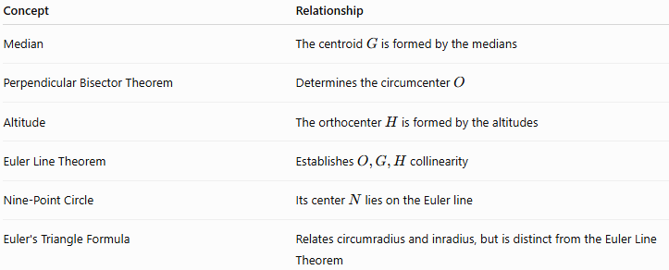
Concept | Relationship
Median | The centroid $G$is formed by the medians
Perpendicular Bisector Theorem | Determines the circumcenter $O$
Altitude | The orthocenter $H$is formed by the altitudes
Euler Line Theorem | Establishes $O,G,H$collinearity
Nine-Point Circle | Its center $N$lies on the Euler line
Euler's Triangle Formula | Relates circumradius and inradius, but is distinct from the Euler Line Theorem

Real-World Applications
# Source: AI Source: Provided by: [Data Path: Persons Table -> ID Column: 1, Name_En Column: Motasem Essam] -> From: [ChatGPT] on [7/25/2026]
The theorem is primarily mathematical, but its underlying relationships are useful in:
- Geometric modeling.
- Computer graphics.
- CAD and geometric construction.
- Coordinate geometry.
- Computational geometry.
- Triangle-based algorithms.
- Structural and mechanical geometry.

Key Points
# Source: AI Source: Provided by: [Data Path: Persons Table -> ID Column: 1, Name_En Column: Motasem Essam] -> From: [ChatGPT] on [7/25/2026]
- The Euler Line Theorem concerns important centers of a triangle.
- The circumcenter $O$, centroid $G$, and orthocenter $H$are collinear.
- Their common line is the Euler line.
- The centroid divides $OH$in the ratio $1:2$.
- Therefore:
$$\boxed{OH=3OG}$$
- The nine-point center $N$also lies on the Euler line.
- In an equilateral triangle:
$$\boxed{O=G=H=I}$$

Conclusion
# Source: AI Source: Provided by: [Data Path: Persons Table -> ID Column: 1, Name_En Column: Motasem Essam] -> From: [ChatGPT] on [7/25/2026]
The Euler Line Theorem reveals one of the most important structural relationships in triangle geometry. It shows that three independently defined centers—the circumcenter, centroid, and orthocenter—are not independent: they always lie on one straight line in a non-equilateral triangle, with the centroid dividing the circumcenter–orthocenter segment in the fixed ratio $1:2$.

